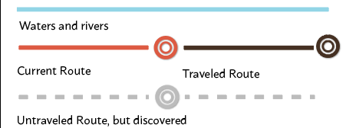



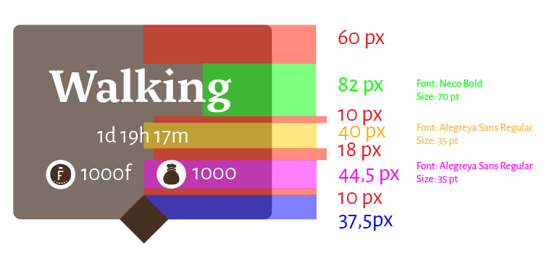

**Fonts:**

Neco

Alegreya Sans

<https://drive.google.com/drive/folders/13tf-9hKrG_y8CYyw0HJLTjj7Snj74_Rs>

**Assets:**

Bubbles and Icos: <https://drive.google.com/drive/folders/15_cVGaIJyivxziHVgIKM4u1btxUSx69s>

**Animation** - Transportation



